
Date of Policy | July 2023
Author | H Boyce
Date approved by Headteacher | July 2023
Review date | July 2024

Attendance Policy

This policy was developed through consultation with the Head teacher, Senior member of staff responsible for Attendance, Academy Attendance Officer and the Education Welfare Officer (EWO). It will be reviewed annually by the Governors’ monitoring committee.

Mission Statement for Attendance

We are committed to ensuring that all families and pupils understand the importance of 100% attendance.
Attendance in school is vital for academic success. Research shows that pupils whose attendance is less than 95% are at risk of failing to achieve 5 GCSEs at grade 4 and above.
For these reasons, we monitor attendance patterns with vigilance and hold parents and carers to account where necessary.
We expect all pupils to attend at all times.

- Promoting good attendance is the responsibility of the whole Academy community; including parents and carers.
- Good attendance is crucial to maximising pupils’ potential, progress and achievement.
- Good attendance is essential if pupils are to take full advantage of school and gain the appropriate skills, which will equip them for life.
- Academy staff will work in partnership with parents and other professionals to improve attendance, to identify vulnerable pupils and to meet the needs of those whose attendance is poor.
- Good attendance will be seen as an achievement in its own right and explicitly recognised as such by school. The attendance policy is based on the premise of equal opportunities for all and promotes inclusion for all pupils.

Practice

- Pupils must arrive in school by 8:35am; tutor time begins at 8:40am.
- Pupils arriving in school after 9am before the registers close at 09.20 will be marked as late.
- Pupils arriving late to school after the register has closed at 09.20 and the school is not satisfied with the reason given will be recorded as unauthorised absence.
- Pupils who are persistently late to school will be investigated, parents will be contacted for an explanation and will be advised that continued lateness after the register closes may result in the issuing of a Penalty Notice.
- Pupils who are late to school if they have been delayed by the school bus will not be marked late.
- Pupils late owing to medical appointments must provide a letter showing proof of appointment.
- Parents and/or carers are expected to notify school of a pupil absence.
- The school must be notified of the reason for a child’ absence in order to safeguard the child and protect their educational well-being.
- In the case of illness, parents and/or carers should phone the school on the first day of absence and every day of absence thereafter.
- The school will contact parents and/or carers on a daily basis if they fail to inform the school of an absence.
- The school will continue to phone home for a period of extended absence, even if the reason for absence is known.
- Family holidays and non-hospital medical appointments, dentist and optician appointments are not permitted during term time. Pupils have 13 weeks’ school holiday per year and further time off on INSET days and so we kindly ask parents and/or carers to use these times to make routine appointments in order to avoid unnecessary absences from school. In accordance with Government and LA guidelines the school will not authorise any absence for holidays. Government legislation from September 1st 2013 states Schools can only grant requests for leave of absence due to exceptional circumstances.
- Pupil’s absence will be recorded as ‘unauthorised’ if we are not satisfied with the reasons for absence. Continued unauthorised absences may result in a fixed penalty notice from the Local Authority.
- For a day set aside exclusively for religious observance, pupils will be granted one day of authorised absence per religious festival. Time taken beyond this will not be authorised.
- The school takes its duty to safeguard the welfare of all its pupils. Unexplained absences and a lack of contact from parents may cause us concern and lead us to involve other agencies such as Children’s Services. We will contact Children’s Services within 2 days for any child with a Child Protection Plan.
- The school carefully monitors attendance on a daily basis and attendance is discussed weekly by the school’s Pastoral Leaders.
- Parental meetings are held to challenge and support our parents in raising the attendance of any child the school has concerns about.
- Where a child is failing to attend school, a plan will be drawn up in consultation with the family and, possibly, external agencies, including Education and Social Welfare workers.
- Pupils who are off school for a long period due to severe illness will be issued with optional work to carry out at home to avoid falling behind.

Absence Procedures

In order to ensure the safety and wellbeing of all pupils, we have a rigorous monitoring system and follow up policy when absences from school occur. They are as follows:

- On the first day of absence, and every day thereafter the school must be notified of the pupil absence and reason.
- When a pupil’s attendance falls below 97% - Stage 1, the Pastoral Team will contact parents/Carers,
- If attendance falls below 93% - Stage 2, the Head of Year will formally contact parents by telephone and follow up letter.
- If attendance is still not improved and falls below 90% - Stage 3, the Head of Year will notify parents/carers that they have been referred to the Educational Welfare Officer.
- Parents will be invited to a formal meeting with the Educational Welfare Officer and Head of Year, parents will be issued with a Fast Track contract Stage 4. This is a formal period of 4 weeks in which attendance must be 100% and an agreed period of time thereafter where attendance must be no less than 97%.
- Further declines in attendance will result in formal hearings with the Deputy Head teacher responsible for attendance and the school’s nominated link Governor.
- Failure to comply with Fast Track will trigger Stage 5 and will result in a Penalty Notice request being issued to the Local Education Authority.

Home Visits

It is a normal and regular part of our communication with all families and pupils and part of our safeguarding duty to make home visits. These may be pre-arranged or, unannounced.

Penalty Notices

Fixed Penalty Notices are served to parents where they have failed to ensure that their child of compulsory school age regularly attends school or is persistently late to school after the registers have closed.
Fixed Penalty Notices are issued to each parent/parents with day to day responsibility for the pupil’s attendance, payable up to £120 per Parent per Child for unauthorised absence.

Parent Information – Late Arrival to School and lessons

Expectation
Pupils will arrive in school on time and be present in Tutor time at 08.40am every day that school is open.

Late Arrival to School and/or Lessons
Pupils arriving late to school must sign in at the Main reception Elmwood on Duffield Road.
Pupils arriving late to school before the register has closed at 09.20 will be recorded as late (L- code).
Pupils arriving late to school after the register has closed at 09.20, and the school is not satisfied with the reason given, will be recorded as unauthorised absence (U - code)

Pupils who are late to school if they have been delayed by the school bus will not be marked late.

Pupils late owing to medical appointments must provide a letter showing proof of appointment.

All late arrivals to School and/or Lesson will be monitored.
Pupils who are persistently late to school will be investigated, parents/carers will be contacted for an explanation and will be advised that continued lateness after the register has closed may result in the issuing of a Penalty Notice.

10 occasions of unauthorised late arrival to school and/or unauthorised absence from school without an acceptable reason School may proceed with requesting that a Penalty Notice is issued by the Local Education Authority, this may result in:

- A Penalty Notice payable up to £120 fine per parent
- Prosecution under s444 (I) Education Act 1996, where if convicted you may be fined up to £1000
- Prosecution under s444 (I)(a) Education Act 1996, where if convicted you may be fined up to £2500 and/or 12 weeks imprisonment.

Parent Information - Absence
It is the parent/guardian/carers responsibility to notify school of a pupil’s absence on the first day of absence, and every day thereafter.
All absences must be reported on 01332 557032 option 1 before 9am.
State the pupil’s name, year group, reason for absence and your relationship to the pupil.
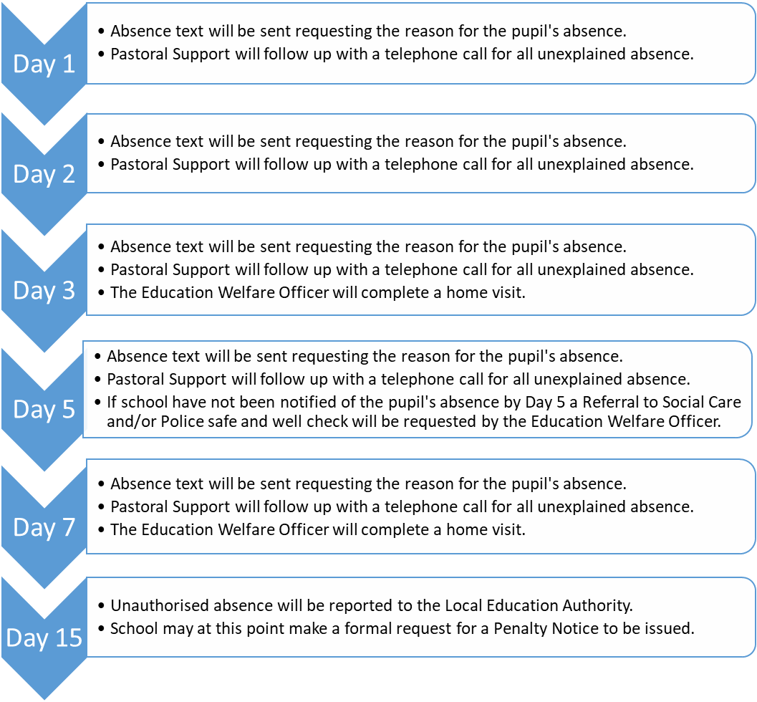
If a parent fails to notify school the following process will be implemented.

Parent - Attendance Process
Expectations
Pupils will attend school and lessons on time and every day that the school is open.
Pupils to achieve 100% attendance.
Pupil Attendance will be monitored from the Start of the Academic Year
