Independence Templates
Thinking hard
Re-visit

Rationale
The increased complexity and content of the newly reformed A Level exams means that effective revisiting is essential if our students are to achieve academic success.
As teachers, our capacity is already stretched to limit, ensuring that content and skills are covered during curriculum time. Our evenings are often busy with intervention and therapy sessions to consolidate knowledge and to prepare students as fully as possible for the rigour of their exams. We teach, challenge, assess, feedback, and intervene in the hope that our guidance will get them through. However, there is a time every year when we must leave our students to their own devices. We must let them go… armed only with their revision guides, some general advice and some well wishes.
Our main concern, for some pupils, is whether they will actually revise enough in the time they have left. Our second concern is whether the methods they use to revisit will be effective. We certainly don’t want our students expending energy and time studying in a way that produces no fruit.
So how can we ensure our students are working effectively outside of the classroom? What does good revisiting look like? The newly reformed exams mean that students will have to recall greater amounts of facts and knowledge quickly. While rote learning and regurgitating content doesn’t lead to deep thinking, we know that firstly the information needs to go in, through memorisation of key facts. Fundamental knowledge needs to be embedded, even imprinted on the minds of students to facilitate quick and easy recall. Next students need to deepen their knowledge through higher-order thinking as information learned and processed through higher-order thinking processes is remembered longer and more clearly than information that is processed through lower-order, rote memorisation. Finally, students need to retrieve, demonstrate, apply and test their learning.
PiXL Revisit is a simple revisiting method that ensures students are preparing for external exams in an effective way. It is based on the three key stages explained above and is arranged around a 10 week cycle.
- Stage 1 - Upload - Embedding the knowledge.
- Stage 2 - Process - Deepening the knowledge.
- Stage 3 - Download - Demonstrating the knowledge.
The strategy comes with a clear and simple methodology as well as revisiting templates to organise the learning. A learning schedule is also provided which can be dictated by the teacher or planned by the students.
This pack contains templates we have produced to embed the “Thinking Hard” devices and use them in the PiXL Revisit Strategy. It also includes a calendar to enable our students to be more independent in their revision. This is most effective when used by individual subjects to ensure that revision is targetted and precise. In the pack we have also included BLANK sheets and sheets with instructions.

Unit / Topic:

Reduce and Transform

1.

2.

3.

4.

5.

Unit / Topic:

Prioritise - Significance and Importance
Key Facts, Dates, Words, Vocab:
3.

1.
Notes:

WHY?

WHY?
Number of Priority:

WHY?

WHY?
2.

4.

WHY?
5.

Unit / Topic:

3 x 2 Testing

Last Lesson
Key facts:
Last Week
Key facts:
Last Year
Key facts:
One topic to revise next:

Unit / Topic:
Process and Categorise
Steps and stages explained

Which is the most important stage?

WHY?

Key Facts / Observations

Unit / Topic:

Chunk It

10
Chunks of learning of this / topic / area
* You could start with the most important or the most difficult to learn
1.
2.
3.
4.
5.
6.
7.
8.
9.
10.

Ranking Triangle

Name of Topic: __________________________________________________________________________________________________
Name: __________________________________________________________________________________________________
Class: __________________________________________________________________________________________________

The most important information goes at the top and then the least important at the bottom. Make sure you justify WHY you think it the most/least important.

Thinking Hard Model
Name of Topic: __________________________________________________________________________________________________

Take a section of the text and do the following:

- Prioritise: Underline the three most important sentences here. Rank 1-3, briefly explain number 1. Cross out the least important sentence

- Reduce: Reduce the key information into 12 words

- Transform: Transform this information into 4 pictures or images (no words allowed)

- Categorise: Sort this information into three categories. Highlight and think of a suitable title for each category.

- Extend: Write down three questions you’d like to ask an expert in this subject.

‘Boxing Up’ Activity

Name of Topic: __________________________________________________________________________________________________
Name: __________________________________________________________________________________________________
Class: __________________________________________________________________________________________________

Read the text and then put your thoughts in to different boxes so that you have ‘boxed up’ the text.

Box 1 – 3 things I did not know

Box 2 – 3 things I understand better now

Box 3 – 3 things I already knew

Question Time

Name of Topic: __________________________________________________________________________________________________
Name: __________________________________________________________________________________________________
Class: __________________________________________________________________________________________________
When you read any text, you should be asking it questions NOT just letting it wash over you. Read your text and pause and ask it questions - e.g. ‘what do you mean when you say ‘….”?’

Questions I’m asking the text |  | Answers to those questions |  | Things I need to ask my teacher
Quizzing
Name of Topic: __________________________________________________________________________________________________
Name: __________________________________________________________________________________________________
Class: __________________________________________________________________________________________________
Read the text and come up with 20 questions to ask someone about the text.
 | Question | Answer
1
2
3
4
5
6
7
8
9
10

Transforming

Name of Topic: __________________________________________________________________________________________________
Turn the material you have read into up to 6 pictures – one per paragraph or one per key piece of information. The pictures must represent the information so that they can act as a reminder of what the text said. Underneath each picture, explain your thinking.

1. | 2. | 3.
4. | 5. | 6.

Now restore your pictures back into its original form.

Chapter theme / topic
Main idea 1
Specific detail A
Specific detail B
Specific detail C
Main idea 2
Specific detail D
Specific detail E
Specific detail F
Specific detail G
Specific detail H
Specific detail I
Specific detail J
Specific detail K
Specific detail K
Main idea 4
Main idea 3

Taken from the article: ‘What Will Improve a Student’s Memory?’ By Daniel T Willingham (http://www.aft.org/sites/default/files/periodicals/willingham_0.pdf)
Unit / Topic:

Transform

Key Points

1.
2.
3.
4.
5.
6.
7.
8.
9.
10.

PICTURE/ SOURCE/ INFO/ RESOURCE

Most important + WHY:
Examine It

Key Dates
Exam Question
NOTES
Topic:
1.
2.
3.
4.
5.
6.
Key Facts
Key Quotes
Key Formulae
Key Words

Title
Flexibility of thinking Connection Map

Title

Flexibility of thinking Connection Map

Draw lines linking the boxes. The darker /stronger the line the stronger the link.
Place the information/ factors/knowledge in the boxes. Add as many boxes as you want to.

On the line give reasons for the links - explain the LINK /importance or significance.

You could also add formula/dates/facts/quotes near or on the line to exemplify knowledge

Experiment Title:
Experiment on a page

Process / Method

1.
2.
3.
4.
5.
6.
7.
8.
9.
10.

Formulae
Label
Label
Label
Experiment Diagram

Results

Unit / Topic:

NOTES:
Transform
Picture

Picture

Unit / Topic:
Reduce to 6 points

Information

Information
Reduce to 6 points

1.
2.
3.
4.
5.
6.
Prioritise (most important)

1.
2.
3.
4.
5.
6.

WHY?
P
R
I
O
R
I
T
I
S
E

Reduce to 3 key points

A.

B.

C.
R
E
D
U
C
E

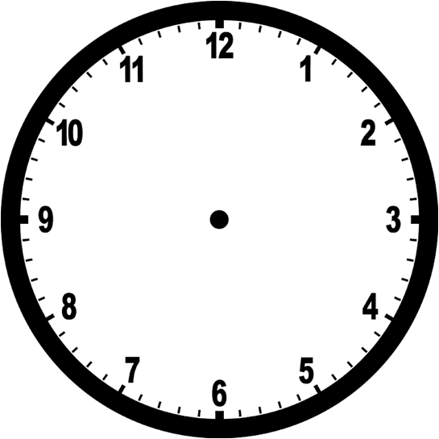

Monday | Tuesday  PiXL Revisit: Chunk It Revision Timetable | Wednesday | Thursday | Friday
Not sure OK Great!  I must recap:  Page number: | Not sure OK Great!  I must recap:  Page number: | Not sure OK Great!  I must recap:  Page number: | Not sure OK Great!  I must recap:  Page number: | Not sure OK Great!  I must recap:  Page number:
Not sure OK Great!  I must recap:  Page number: | Not sure OK Great!  I must recap:  Page number: | Not sure OK Great!  I must recap:  Page number: | Not sure OK Great!  I must recap:  Page number: | Not sure OK Great!  I must recap:  Page number:

PiXL Revisit: Chunk It Revision Timetable

PiXL Revisit: Chunk It Revision Timetable,

